# Predictions. Degrees of certainty

# Ways technology will change our lives by 2050

By [Danielle Muoio](http://www.businessinsider.com/author/danielle-muoio), 2016

<http://www.businessinsider.com/ian-pearson-predictions-about-the-world-in-2050-2016-7/#we-could-start-seeing-delivery-drones-finally-start-making-deliveries-in-the-next-two-years-1>

**Task 1. Read the following predictions and decide whether the statements in italics are true or false, according to the text.**

New forms of technology are bound to change how we live. We asked Ian Pearson, a futurist with an 85% accuracy record, what new technology we can expect to see by 2050 and how it will change the way we live. Scroll down to see Pearson's biggest predictions about the future:

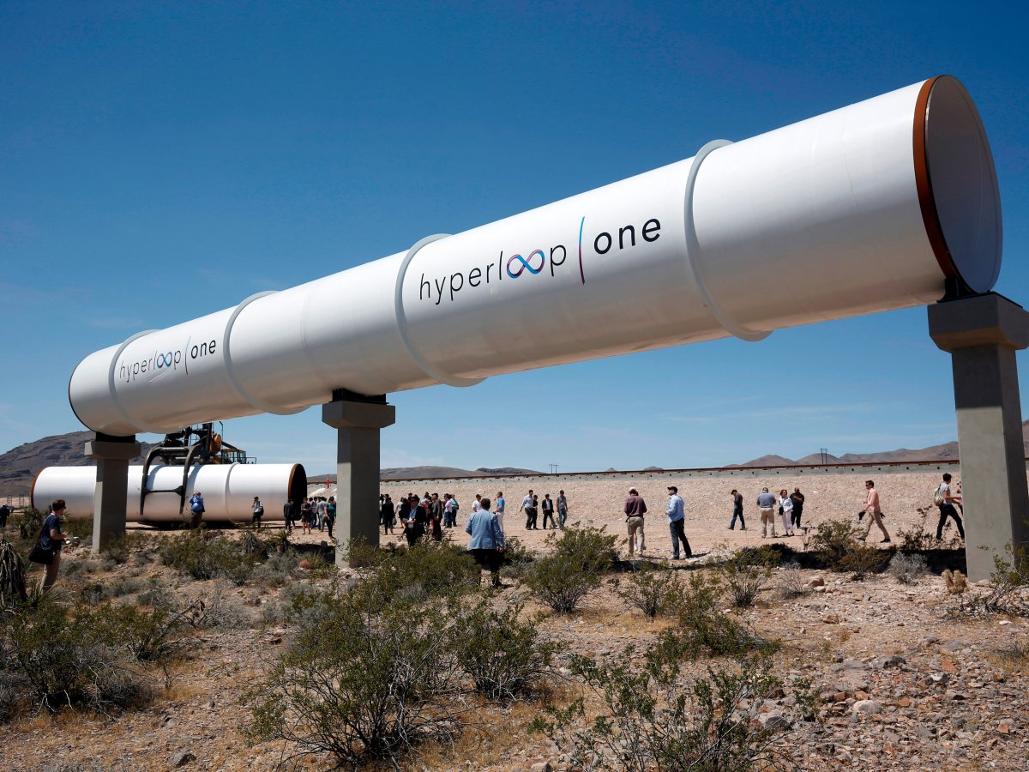

### 1. A Hyperloop could take us in between cities in just six years.

We already know we're getting closer to seeing a Hyperloop, a high-speed propulsion system, after seeing the [first test run by start-up Hyperloop One](http://www.techinsider.io/hyperloop-test-video-2016-5) in May. Hyperloop One has actually partnered with the City of Moscow to [bring one to Russia](http://www.techinsider.io/hyperloop-one-summa-make-deal-with-moscow-2016-6).

Pearson said he expects to see a short-range Hyperloop that transports people between two cities in five to six years’ time.

*Hyperloop will have transported people between two cities by 2024. True or false? true*

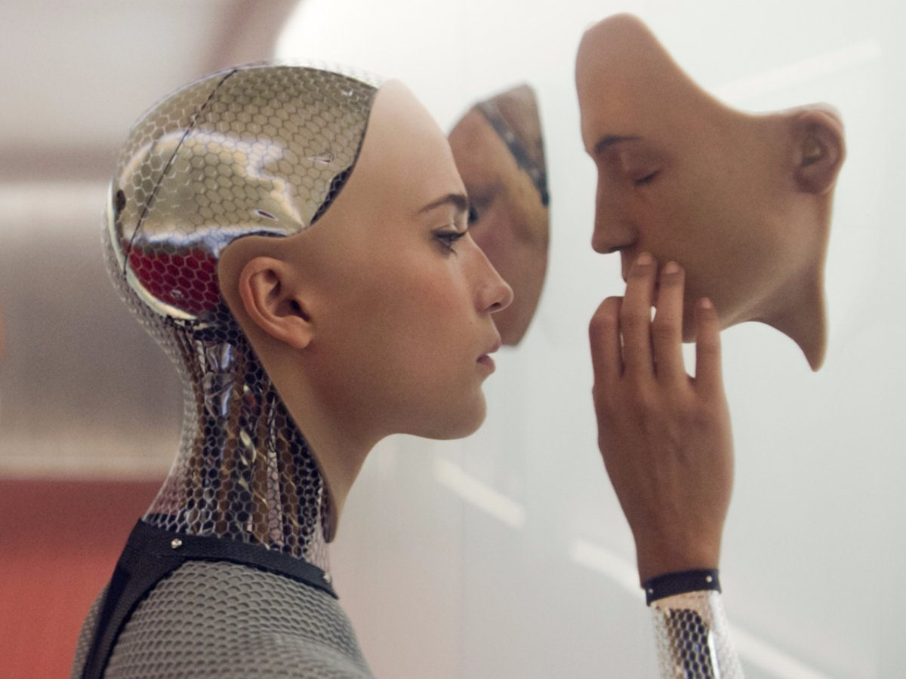

### 2. Machines could start thinking like humans as early as 2025.

Pearson said he thinks it's very feasible that computers could gain consciousness by 2025, perhaps even earlier in 2020.

"Google's DeepMind isn't there yet, but really I'm sure they'll probably discover those things along the way, and by 2020, it's possible their computer could be superhuman and could be conscious," he said. "That could be the beginning of the end, really."

*Computers could be conscious in 2020. True or false? true*

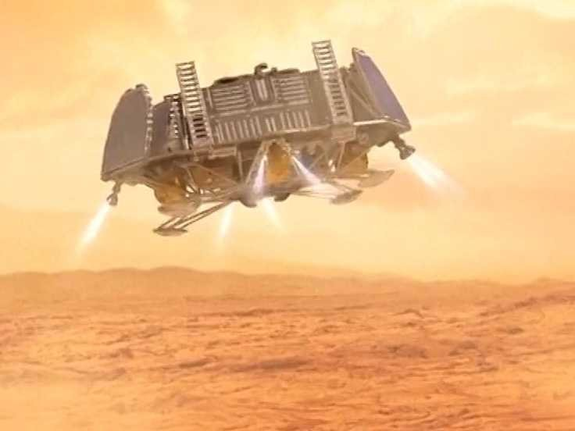

### 3. Space trips designed to send people to Mars could start taking place in 2030.

That prediction actually gives Musk some leeway in realizing his vision of getting people to Mars. Musk said at Vox's Code Conference in June he plans to [send astronauts to the red planet in 2024](http://www.techinsider.io/elon-musk-humans-mars-mission-2025-spacex-2016-6) so they get there by 2025.

"We will see first people going off to Mars, and then robots will do some basic stuff like making basic materials [on Mars,]" Pearson said. "We're going to have to do that because only so much can be brought to space."

*Basic materials will be brought to space. True or false? false*

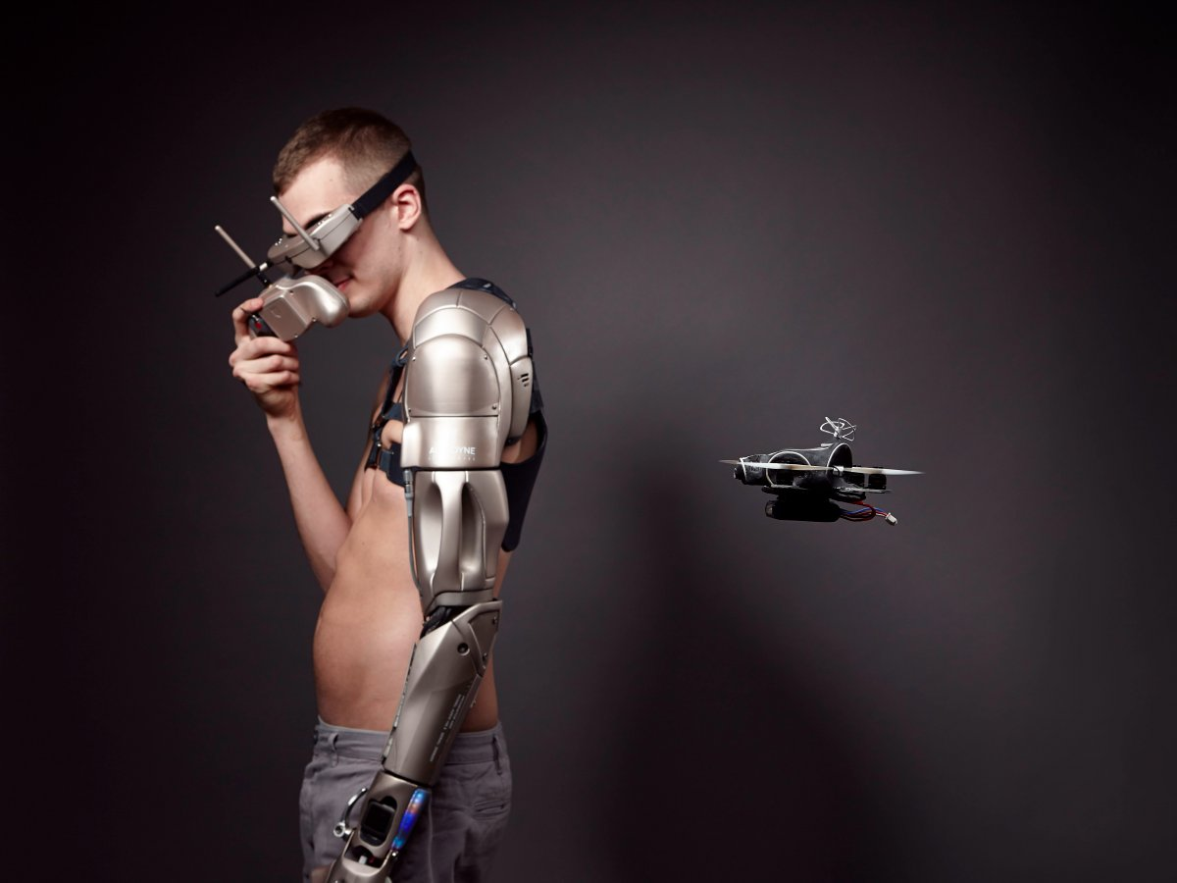

### 4. Prosthetics could get so advanced in the next 10 years they could give people new skills.

We've started seeing people use advanced prosthetics already. James Young, a 25-year-old biological scientist, has a [prosthetic arm with a personal drone](http://www.techinsider.io/bionic-arm-from-alternative-limb-project-has-drone-2016-6) and built-in flashlight. And a French artist is using a [prosthesis that doubles as a tattoo gun](http://www.techinsider.io/artists-prosthetic-arm-is-a-tattoo-gun-2016-6).

Pearson said prosthetics will continue to get more advanced to the point where people are fully comfortable with technology merging with the body. For example, he said people could choose to get cybernetic implants in their legs to make them stronger.

*In 10 years’ time prosthetic arms will include flashlights. True or false?false*

**Task 2. Translate into English.**

*1. Es seguro que nuevas formas de tecnología cambiarán nuestra vida.*

*New forms of technology are sure to change our lives.*

*2. Es probable que los astronautas viajen a Marte en 2024.*

*Astronauts are likely to travel to Mars in 2024*

*3. Es posible que los ordenadores empiecen a pensar como las personas en el 2025.*

***Computers are likely to start thinking as humnas in 2025***

Computers Will certainly start thinking as humans in 2025

*4. La gente que necesite una prótesis podrá elegir implantes cibernéticos para* ***fortalecer****, por ejemplo, la pierna o el brazo.*

*Peopple who need a prosthesis Will be able to choose cybernetic implants to* ***strengthen****, for example, the leg or the arm.*